PIZZA SALES SQL QUERIES

1. KPI’s
2. Total Revenue:

select sum(total_price) as Total_Revenue from pizza_sales;

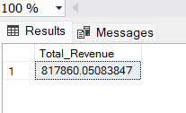

1. Average Order Value:

select sum(total_price) / count(distinct(order_id)) as Average_Order_Value

from pizza_sales;

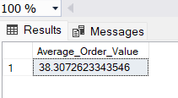

1. Total Pizzas Sold:

select sum(quantity) as Total_Pizza_Sold from pizza_sales;

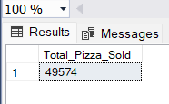

1. Total Orders:

select count(distinct order_id) as Total_Orders from pizza_sales;

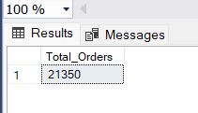

1. Average Pizzas Per Order:

select cast(cast(sum(quantity) as decimal(10, 2))/ cast(count(distinct order_id) as decimal(10, 2)) as decimal(10, 2)) as Average_Pizzas_Per_Order from pizza_sales;

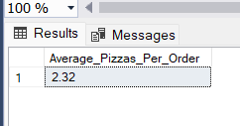

1. Daily trend for total orders

select DATENAME(DW, order_date) as order_day, count(distinct order_id) as Total_Orders

from pizza_sales

group by DATENAME(DW, order_date);

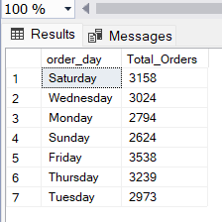

1. Hourly Trend for orders:

select DATEPART(HOUR, order_time) as order_hours, count(distinct order_id) as Total_Orders

from pizza_sales

group by DATEPART(HOUR, order_time)

order by DATEPART(HOUR, order_time);

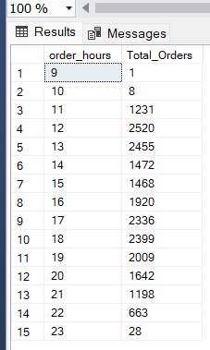

1. Percentage of sales by pizza category:

select pizza_category, sum(total_price) as Total_Sales, sum(total_price) * 100 / (select sum(total_price) from pizza_sales) as Percentage_Sales

from pizza_sales

group by pizza_category;

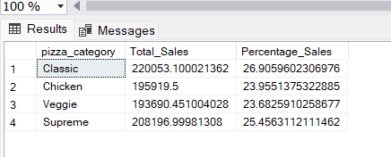

1. Percentage of Sales by Pizza Size:

select pizza_size, sum(total_price) as Total_price, cast(((sum(total_price) * 100) / (select sum(total_price) from pizza_sales)) as decimal(10, 2)) as Percentage_Sales

from pizza_sales

group by pizza_size;

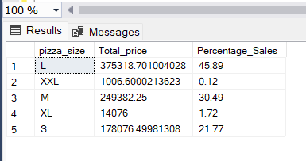

1. Total pizzas sold by Pizza Category

select pizza_category, sum(quantity) as Total_Pizzas_Sold

from pizza_sales

group by pizza_category;

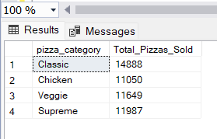

1. Top 5 best sellers by total pizzas sold.

select top 5 pizza_name, sum(quantity) as Total_Pizzas_Sold

from pizza_sales

group by pizza_name

order by sum(quantity) DESC;

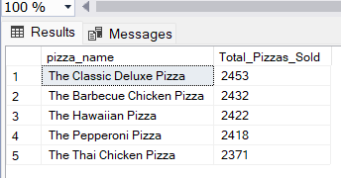

1. Worst 5 seller by total pizzas sold:

select top 5 pizza_name, sum(quantity) as Total_Pizzas_Sold

from pizza_sales

group by pizza_name

order by sum(quantity);

